TODO

Deal with all XXX points in the document

Assessing the Impact of Continuous Traits on the Evolution of Discrete Traits: The Ancestral Condition Test.

Running title: ACT

Nathan Anderson1, Richard H. Adams2, and Heath Blackmon3,4

1 Department of Math, 3368 TAMU, Texas A&M, College Station, TX 77843 USA

2 Department of Biology, 501 S. Nedderman Dr., University of Texas at Arlington, Arlington, TX 76019 USA

3 Department of Biology, 3258 TAMU, Texas A&M, College Station, TX 77843 USA

4 coleoguy@gmail.com

**ABSTRACT**

Co-evolutionary relationships where the value of a continuous trait affects the evolution of a discrete trait remain difficult to study. We present a novel comparative method that tests whether a discrete trait transitions when a continuous trait has values more extreme than expected if both traits were evolving independently. We show that this approach has acceptable false positive rates but has low power unless the sample size is large. We also explore the robustness of our approach under a range of patterns of trait evolution. We find that when the discrete trait evolves unidirectionally power is higher relative to bidirectionally evolving trait. Finally, we compare this approach to existing methods that can be used to explore similar hypotheses. The types of questions that this approach allows us to test are common in evolutionary biology and, unlike existing approaches, the ancestral condition test uses all available data and ,unlike existing methods, provides information on the direction of causality.

**INTRODUCTION**

One of the central goals of evolutionary biology is to understand the evolution of traits among species. With the advent of statistically robust methods of phylogenetic tree inference, we can now fit probabilistic models to the evolution of both discrete traits (Lewis 2001; Felsenstein 2012) and continuous traits (Felsenstein 1985; Butler and King 2004; O'Meara et al. 2006; Landis et al. 2012). A variety of methods that test for correlations between multiple continuous traits have been developed (reviewed in Felsenstein 2004). Robust method are also available to study the way that a discrete character impacts the evolution of a continuous trait (O'Meara et al. 2006). However, methods available to identify and analyze a co-evolutionary relationship where a continuous trait affects the evolution of a discrete trait are less well developed (but see Hadfield 2010; Felsenstein 2012; Revell 2014).

Hypotheses that ask whether extreme values of a continuous trait are associated with transitions in a discrete trait are common in evolutionary biology (Ross et al. 2012; Blackmon and Demuth 2015; Blackmon et al. 2015). For instance, in a recent study of sex chromosome evolution, we were interested in testing whether loss of the Y chromosome, a discrete transition, occurred in taxa with a significantly higher total number of chromosomes, a continuous trait, than would be expected if the two were unrelated (Blackmon and Demuth 2015). A number of existing approaches might be employed in such a situation. First, by discretizing chromosome number into a low and high category, we could apply Pagel’s test for the correlation of two binary characters (Pagel 1994). This approach is problematic, however, as defining threshold values for high and low classes involves arbitrary decisions that may not reflect biological reality, and if several threshold values are tested, p-values should be corrected for multiple comparisons. Additionally, by discretizing a continuous variable we effectively reduce the amount of data being applied to the problem and decrease our power to detect a significant relationship. Another approach would be to assume that our discrete state (presence or absence of a Y chromosome) could be modeled as if it was produced by an underlying continuous trait that we cannot observe. If this assumption is justified, we could employ the threshold model (Wright 1934; Felsenstein 2012). This approach would allow us to estimate the correlation between chromosome number and presence or absence of the Y chromosome. A third approach would be to use a phylogenetic mixed model treating chromosome number as a predictor variable and presence or absence of the Y chromosome as a response variable (Hadfield 2010).

However, each of these approaches as commonly applied suffer from the same fundamental problem: correlation does not provide information about the direction of causality. For example, does high chromosome number lead to Y chromosome loss or does Y chromosome loss lead to high chromosome number? Beyond this many of these methods suffer from excessive false positive rates (Maddison and FitzJohn 2014).

In light of these issues, we have developed a flexible, conservative statistical test to infer significant relationships between the value of a continuous trait and transitions in a discrete trait. The flexibility of our approach comes from the fact that we can choose to estimate ancestral states of the continuous trait using all data or, in cases where there is a clear derived and ancestral condition, we can restrict our estimate of the continuous trait to only use data from species that have retained the ancestral condition of the discrete trait. This approach allows us to control for the biological reality that there may be feedback where the derived condition of the discrete trait can impact the evolution of the continuous trait. In practice, there is not always a clear ancestral and derived state particularly when a discrete character evolves quickly and lacks fossil data. This does not pose a problem for the approach that we have developed but in such cases the power of our approach is reduced. Our approach allows us to get closer to the ultimate question of causality than do existing methods. Finally, we assess significance through an empirically informed simulation approach that addresses the well documented problem of excessive false positives.

Briefly, our approach estimates the mean value of the continuous trait when the discrete character transitions and we evaluate the significance of this mean value by comparison to a null distribution, which is simulated as if there is no relationship between the two traits being studied. We apply our ancestral condition test to simulated traits using both simulated and empirical trees, and we find that our method is conservative but has relatively low power unless both the number of taxa and the degree of contingency between traits is large. In comparison to existing methods our approach proves to be twice as powerful as Pagel’s test, the next most powerful test, while also granting insight into causal relationships between traits. We believe that the ancestral condition test offers a valuable addition to the phylogenetic comparative method universe, applicable in many cases where the evolution of a discrete character may be influenced by the state of a continuous trait.

**METHODS**

*The Ancestral Condition Test*

Our approach determines whether there is evidence that nodes, in the phylogenetic tree, subtending transitions of a discrete character tend to exhibit extreme values of the continuous character under study. We refer to this method as the Ancestral Condition (AncCond) test, which involves the following four steps:

1) Estimate the ancestral values of the continuous character while optionally pruning data from species that exhibit the derived state of the discrete character. By pruning data from taxa exhibiting the derived state of the discrete character, we create a more conservative test that will be applicable in cases where the derived state of the discrete character is expected to lead to changes in the selective forces acting on the continuous character. Ancestral state estimation is accomplished under a Brownian motion model using the existing function anc.ML of phytools (Fig. 1A) (Revell 2012).

2) Next, we perform ancestral state estimation of the discrete character by way of stochastic character mapping (Fig. 1B) (Huelsenbeck et al. 2003; Bollback 2006). We may choose to fix a single state at the root of the tree in cases where this is appropriate. For instance, when the fossil record or prior biological knowledge suggests that transitions are expected to occur in one direction (Blackmon et al. 2015). In the latter case, users may also restrict the simulated evolution of the discrete character by allowing only transitions from the ancestral to the derived state. Stochastic mapping is performed using phytools’ make.simmap function (Fig. 1B) (Revell 2012). For simplicity we will refer to the two states as 1 and 2, state 1 will be assumed to be the ancestral state, and state 2 the derived state when discussing unidirectional evolution.

3) We then process the stochastic maps to classify all nodes in the tree into one of three groups: a) Nodes exhibiting state 1 of the discrete character and no transitions in discrete character in immediate daughter branches (Fig. 1C, blue nodes), b) Nodes exhibiting state 2 of the discrete character and no transitions in discrete character in immediate daughter branches (Fig. 1C, green nodes), c) Producing nodes exhibiting one state of the discrete character but with one of the immediate daughter branches showing a transition into the other state of the discrete character (Fig. 1C, red nodes). In the bidirectional case, we then parse producing nodes to select those that subtend branches with transitions from state 1 to state 2 or from state 2 to state 1. In the unidirectional case this parsing is not necessary. Next, we calculate the mean value of the continuous trait at the producing nodes in each group, identified across stochastic mappings and (if available) a distribution of trees, incorporating both phylogenetic and ancestral state estimation uncertainty. This mean of producing nodes is our observed statistic. We refer to this value as the “estimated ancestral condition” for each of the states of the discrete character (Fig. 1C). In the case where transitions are restricted to a single direction, there will be a single estimated ancestral condition for transitions from the ancestral to the derived state. In the more general case, there will be two estimated ancestral conditions for transitions from state 1 to state 2 and for transitions from state 2 to state 1.

4) We construct a null distribution by sampling the ancestral state estimate for the continuous trait from all nodes in the correct discrete trait. The number of nodes sampled is the same as the number of producing nodes sampled for the observed statistic. This sampling process is repeated a default of 1000 times. These simulated mean ancestral condition values define the null distribution. Finally, we compare the mean ancestral condition to this null distribution to obtain a p-value (Fig. 1D).

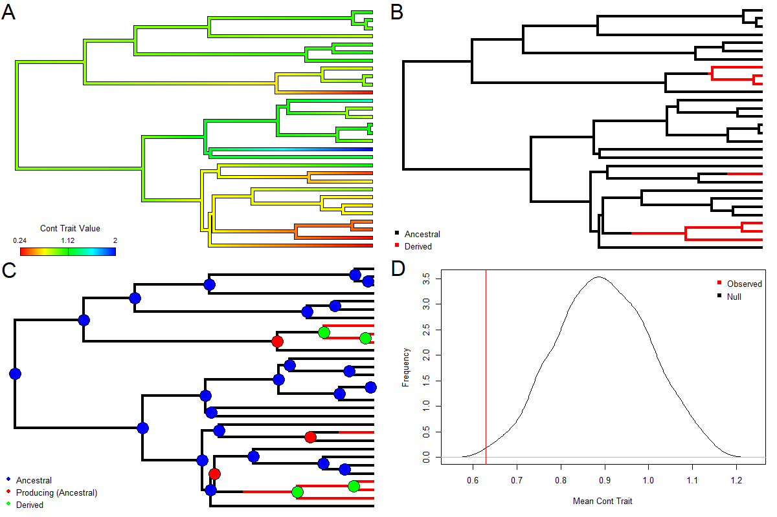

Figure 1. Four steps in the ancestral condition test. A) Ancestral state estimation of the continuous character assuming a Brownian motion model of evolution. B) Identification of the transition points in the discrete character through stochastic mapping C) Categorization of nodes as either ancestral or derived as well as those that subtend an origin of the derived state of the discrete character. D) Depiction of the null distribution and the observed mean of producing nodes estimate from the data. In this example the producing nodes have a lower continuous value than expected if there is no relationship between the traits.

***Simulated data***

*Scenario one–unidirectional change in a discrete character*

We simulated 100 trees using a birth-death model with a birth rate of 3.0 and death rate of 1.0, allowing trees to grow until 200 extant species were reached. Phylogenies were rescaled to unit length. Trees were simulated using function trees in Diversitree (FitzJohn 2012). Next, we simulated a continuous character evolving by Brownian Motion with a rate parameter of 0.2 and a starting mean of 0 on each tree using the function sim.char in Geiger (Harmon et al. 2008). We then used the function anc.ML in Phytools (Revell 2012) to estimate the mean value of the continuous trait along each branch of the phylogeny.

To simulate the discrete trait, we used a branch scaling approach. We first identified those branches that had a mean value of the continuous trait in the upper or lower quartiles. Branches whose mean was in the lower quartile were scaled by a multiplicative factor of 1/x while branches in the upper quartile were scaled by a multiplicative factor of x. We repeated this process for ten values of x ranging from 1 to 10 on each of our 100 trees. We then simulated the evolution of the discrete character on these scaled trees. We set the root to state to 1 (ancestral state) and allowed the trait to evolve under a Mk2 model where transitions to state 2 (derived state) were allowed, but not transitions from state 2 to state 1. This pattern of evolution matches our expectations for the type of characters we believe this approach may be most useful. This simulation is done using the sim.char function from Geiger (Harmon et al. 2008). Various transition rates from state 1 to state 2 were evaluated and we found that a rate of 0.1 was sufficient to ensure that multiple transitions occurred in all simulated datasets. If a dataset did not contain at least 10 extant taxa exhibiting each state of the discrete character, it was discarded (Between 6% and 55% of simulations were discarded for a given scaling factor, with a greater percent being discarded for smaller scaling factors). Thus, our total of 1,000 simulated datasets consisted of 10 degrees of contingency each applied to 100 trees,

By simulating the evolution of the discrete trait on these scaled trees, we generated a contingency between the discrete and continuous traits. There exists more opportunity for transitions in the discrete trait to occur on the stretched branches, or equivalently on the branches where the continuous trait value is in the upper quartile. Alternatively, there exists less opportunity for transitions on the branches where the continuous trait value is in the lower quartile, and the branch length was scaled down. This branch scaling technique effectively altered the rate of evolution of the discrete trait wherever the continuous trait took extreme values, increasing the density of transitions on branches where the continuous trait had high values and decreasing the density for branches with low values.

To assess the relationship between the number of taxa included in an analysis and the performance of our approach, we simulated birth-death trees and continuous characters using the methods described above but with tree sizes that ranged from 20 to 200 taxa in increments of 20. We then simulated discrete datasets with a scaling factor of 1 and 5 as described above allowing us to measure both power and false positive rate. If a dataset did not include at least five extant taxa in each state of the discrete character it was discarded and a new dataset was generated (between 11% and 90% for different sized trees, with small trees leading to large increases in the proportion of discarded simulations). A total of 200 data sets (scaling factors of 1 and 5) were generated for each of the 10 tree sizes for a total of 2000 simulated datasets.

*Scenario two – bidirectional change in a discrete character*

We also used simulated data sets to test our method’s performance when a discrete character has transitions in both directions and we are unable to confidently assign an ancestral derived relationship. We repeated the above procedure with two key differences. First, we did not fix the root of the tree to any one state, instead we allowed the root to take either state with equal probability. Second, we allowed for transitions in either direction, from state 1 to state 2 and from state 2 to state 1, with equal rates. A transition rate of 0.3 was used to ensure there were several forward, and reverse transitions in every dataset.

*Scenario three – empirical phylogeny*

To test whether our approach is impacted when trees that are generate by more complex processes and continuous traits have variable rates of evolution we used a phylogeny of living cetaceans (Steeman et al. 2009) and body size data for 74 species (Slater et al. 2010). We then simulated the unidirectional evolution of a discrete character, from a known ancestral state, whose evolution is completely independent of the continuous character using the sim.char function from Geiger (Harmon et al. 2008).

*Assessing performance of comparative tests*

We analyzed these data sets using our AncCond function implemented in the R package EvobiR (Blackmon 2015). We supplied this R function with the unaltered phylogenetic trees and the corresponding tip data of the discrete and continuous traits. For the case of unidirectional evolution, scenario 1, we set the rate of evolution from state 2 to state 1 to zero and fixed the root of the tree to state 1. We also chose to prune continuous data from taxa exhibiting the derived state of the discrete character. This is not entirely applicable to this simulated data, as the continuous character was simulated completely independently of the discrete character. However, we chose to utilize this option in our analysis because, in practice, it is not always clear when the continuous character’s evolution is entirely independent of the discrete character’s, and because it is important to test our method under the most conservative conditions. When assessing data generated under scenario two, we followed the same approach but allowed two separate rates of for transitions in the discrete trait, made no assumptions on the original state at the root of the tree, allowed for two rates in the evolution of the discrete trait (from 1 to 2 and 2 to 1), and pruned no data. In assessing the data from scenario three we followed the same procedure as for scenario one.

For comparison with existing approaches we used two approaches. First, we applied the threshold model as implemented in phytools. This approach allowed us to test for a correlation between our continuous character and the discrete character by inferring an underlying continuous value that we observe as a discretely expressed character. Second, we discretized our continuous character at the median value and applied Pagel’s test for correlation of discrete character also implemented in phytools. Below we show the performance of our approach with the simulated data, reporting both false positive rate and power. Tests were considered statistically significant at a p-value ≤ 0.05 for data analyzed under scenario one and four but at a p-value of ≤ 0.025 for scenario two. The reduction in p-value accounts for the fact that we do not have an apriori hypothesis about whether it is high or low values that lead to significant differences in the rate of evolution in the discrete character. All analyses were completed with RStudio version 1.1.463 running R version 3.5.2 on a windows computer with 16GB of 1200 MHz RAM and a 3.2 GHz processor (R Development Core Team 2013; Team 2015).

RESULTS

Scenario one - Unidirectional change in the discrete character

Analysis of the 100 simulated datasets with a scaling factor of 1 (no contingency between the two traits) showed a reasonable false positive rate of 6% (Figure 2, solid line). Analysis of the datasets with the scaling factor ranging from 2-10 allowed us to assess the power of this approach for increasing degrees of contingency between the discrete and continuous characters. We found that under scenario one power ranged from 15% (scaling factor of 2, weakest relationship) to 78% (scaling factor of 8, strong relationship). In our initial analyses scaling factors of 9 and 10 had power slightly less than scaling factor 8. We performed subsequent analyses and found that scaling factors of 8, 9, and 10 all produce power of approximately 78%, and that the slight reduction in power on scaling factors of 9-10 is simply due to finite sample size of our analyses. The power of 78% likely indicates the maximum power of our approach to detect increasingly strong contingency in 200 species phylogenies. We also calculated the performance of existing methods to detect correlation using data sets simulated with scaling factors of 5 and 1. Pagel’s Test and the Threshold test reported a power of 22% and 12%, respectively, and type 1 error of 7% and 18%. Under these same conditions, AncCond has a power of 50% and a type 1 error of 6% (Figure 2 scaling factor of 5 and 1).

The number of taxa included in comparative analyses often varies by orders of magnitude. We found that our ancestral condition test requires moderately large sample sizes to reliably detect a significant relationship. Figure 3 shows that when our simulated phylogenetic trees consisted of 20 extant taxa, we were only able to detect a significant relationship 4% of the time (Figure 3, solid blue line), a reduction in power of approximately 93% relative to the maximum power found in this analysis, 58% found when 180 taxa were present (figure 3). This was the only analysis where the power of our approach reached over 50%, surprisingly the power again dipped below 50% with 200 taxa (figure 3 ), Again, this loss of power did not persist for subsequent trials.

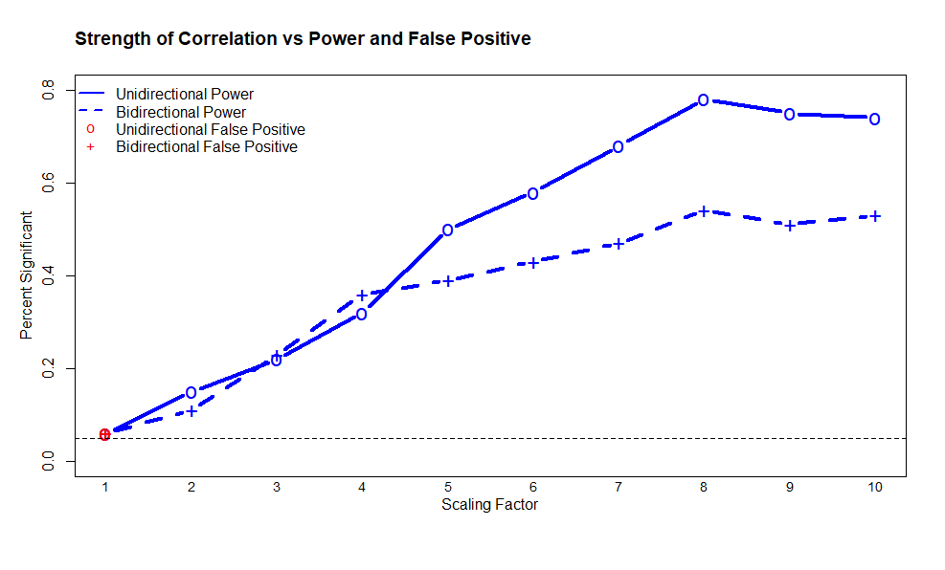

Figure 2. Scaling factor used to generate discrete traits (where higher values indicate greater contingency between traits) plotted against the proportion of simulations for which AncCond detected significant contingency. For a scaling factor of 1, this proportion represents the false positive rate of our method, indicated in red. For scaling factors greater than 1, the significant results are warranted and represent the power of AncCond to detect different strengths of contingency in evolution, indicated in blue. The solid line denotes the performance of our test in scenario 1, the dotted line scenario 2. The thin, dotted black line marks 5%.

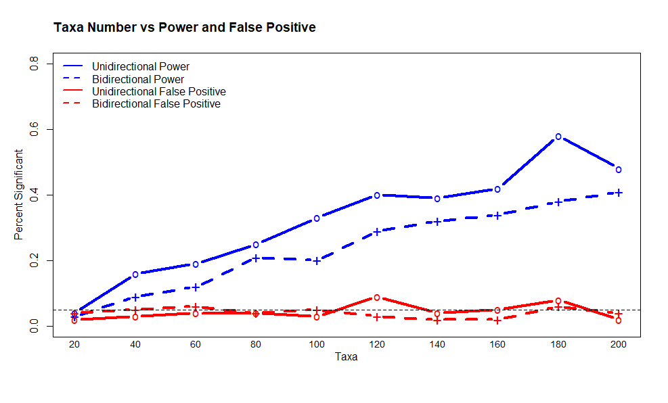

Figure 3. Number of extant taxa included in the analysis plotted against the proportion of simulations for which AncCond detected significant contingency. Red lines the false positive rate, and blue represent the power, calculated by analyzing datasets simulated using scaling factors of 1 and 5 respectively. Solid lines represent AncCond’s performance in scenario 1 and dashed lines represent scenario 2. The thin, dotted black line marks 5%.

Scenario two - Bidirectional change in the discrete character

To test the false positive rate of our method when its assumptions are violated, we analyzed 100 phylogenetic trees and datasets simulated with a scaling factor of 1, we found a false positive rate of 6% (figure 2 scaling factor of 1). Analysis of the datasets simulated with scaling factors 2 - 10 allowed us to analyze the power of our method under increasingly strong relationships between the continuous and discrete characters. We found power ranging from 11% (scaling factor of 2, weakest relationship) to 54% (scaling factor of 8, strong relationship). These power estimates were calculated with a level of significance alpha = 0.025 to correct for testing for correlation in two directions.

We confirmed the ancestral condition test requires a large sample size in the bidirectional case as well. For small phylogenies, the ancestral condition test has power in the single digits and only ever reaches a power higher than 40% when there are 200 taxa present (Figure 3, dashed blue line), the highest value tested. However, false positive remains less than 6% even for extremely small tree sizes (Figure 3, dashed red line).

Scenario 3 - Empirical Phylogeny

Our approach has similar performance when applied to simulated data sets and when applied to empirical phylogenies. Of the 100discrete characters, whose evolution is independent of body size, the Ancestral Condition test detected correlation (alpha = 0.05) in 7 of these cases. This result indicates that our method has a type 1 error of 7% when applied to an empirical phylogeny (Not shown). This value is not considerably different than the type 1 error found using simulated data, indicating AncCond performs similarly with simulated and empirical phylogenies.

DISCUSSION

Our simulation study demonstrates the conservative nature of our ancestral condition test, which has acceptable false positive rates but relatively low power when sample size is small. In situations where no true relationship exists between the origin of a derived state of a discrete trait and the value of a continuous trait (scaling factor of 1), our test will incorrectly identify a significant relationship 6% of the time. However, with a scaling factor of 5, branches with a high continuous value effectively have a transition rate into the derived state of the discrete trait that is 5 times higher than intermediate branches and 25 times higher than branches with a low continuous value. Arguably a very strong relationship, but even in this case we detect the relationship in only 50% of simulated datasets.

The AncCond test becomes more conservative when the assumption of unidirectional evolution is violated. For the greatest scaling factor, or equivalently the strongest correlation, tested, the power reduced from 74% to 53% when we allowed for bidirectional evolution. However, the false positive rate remains a moderate 6% in both cases. The test is able to identify correlation in the evolution of traits with a high degree of certainty however, the power of the ancestral condition test to detect even strong correlation in bidirectional evolution limits the test’s applications in those scenarios. Put simply, whenever the ancestral condition test detects correlation, there is a 94% chance it is correct, but when it does not detect correlation then it is correct 3 out of 4 times, at best.

While current approaches for jointly analyzing continuous and discrete traits are effective in finding correlations, our novel approach provides an important and useful extension to current comparative methods as it explicitly provides information about the order in which traits evolved across a phylogenetic tree. Our approach is robust to possible confounding effects the discrete trait exerts on the continuous trait by only using continuous trait values from taxa that exhibit the ancestral version of the discrete state we are explicitly asking if there is evidence in these taxa that the species exhibiting the derived state originated among lineages with continuous trait values that are significantly different from what we would expect if both traits were evolving independently. Like many comparative methods, the power of the ancestral condition test is dependent on having a sufficiently large tree with transitions in the discrete character. However, the type 1 error remains acceptable even for the smallest phylogenies tested.

Our approach assumes a Mk2 model for the evolution of the discrete trait and a Brownian motion model for the evolution of the continuous trait. The Mk2 model implemented assumes a discrete character that has an ancestral and derived state and does not experience reversion. It would be straightforward to extend our approach to allow for other models for the discrete trait; however, more complex models will often lead to greater uncertainty in ancestral state estimates and thus lower power to detect significant relationships. The adequacy of these underlying models should be evaluated prior to using the ancestral condition test. Model adequacy of the continuous trait can be accomplished in a number of ways (Garland, Harvey & Ives 1992; Purvis & Rambaut 1995; Pennell et al. 2014). Perhaps the most robust of these methods involves first calculating test statistics on the phylogenetic independent contrasts from the observed data. Simulations are then performed and these same test statistics are calculated for each simulation - generating null distributions. The benefit of this approach is that deviation of observed test statistics can not only determine if a model is adequate, but also may provide information about what type of alternative model might perform better (Pennell et al. 2014). Evaluation of model adequacy for discrete traits is currently less developed. One option is to use a Monte Carlo approach to determine if the model and parameter estimates are able to generate data with similar proportions of taxa in each discrete state (Price et al. 2012; Blackmon & Demuth 2014). An additional approach is to examine the number of state changes expected under parsimony for the observed data and compare this to the number of state changes expected under parsimony for simulated datasets (Beaulieu, O'Meara & Donoghue 2013).

Many comparative methods can suffer from pseudoreplication (Maddison & FitzJohn 2014), returning significant results when some would argue that they should not (increased type I error rates). Our ancestral condition test could suffer from such shortcomings. For example, one could imagine a situation where the most recent common ancestor of a clade evolved a higher value for the continuous trait, followed by the evolution of an additional trait that increased the probability of transitions to the derived state of the discrete state. Such a pattern could conceivably produce a significant result despite having only a single origin for the high continuous trait value. We believe the best approach to avoiding the errors associated with pseudoreplication is thorough data exploration prior to applying nearly any comparative method, including our ancestral condition test. There are many tools now available that allow simultaneous visualization of trees and data that can be useful in early stages of an analysis to alert researchers of possible issues. An alternative approach to solving the pseudoreplication problem is to perform what is effectively a meta-analysis . With this approach the original dataset is divided into a number of independent data sets and the results of all of the independent tests can be evaluated (Mayrose et al. 2011).

We have implemented ancestral condition test in the R package EvobiR which is publicly available and can be installed directly from GitHub. This package includes a variety of other useful function in evolutionary biology (table 1).

Table 1 Summary of EvobiR functions

Function Description

Applied Phylogenetics

AncCond Tests whether a derived state of a binary character originates when a continuous character has extreme values.

PPSDiscrete Produce posterior predictive datasets based on log files from programs such as BayesTraits or diversitree.

Population Genetics

CalcD Test of introgression implementing an algorithm described in (Durand et al. 2011)

WinCalcD Sliding window version of CalcD

CalcPopD Test of introgression implementing an algorithm described in (Durand et al. 2011)

Miscellaneous

ResSel For use in selection experiments identifies those individuals for high or low selection lines after regression of one trait on another.

SampleTrees Processes large nexus files, removing burn-in, randomly sampling, and saving in various formats.

FuzzyMatch Identifies records in trees and trait dataset that may be lost due to differences in spelling.

Even Tests whether a number is odd or even

Mode Returns the most common value in a numeric or character vector

SlidingWindow Applies any function that operates on a vector to a sliding window across a vector

AICc Calculates the small sample size corrected version of the Akaike information criteria based on the log likelihood, number of model parameters and sample size.

SuperMatrix Combines multiple alignments with varying taxa sets into a single supermatrix.

Pedagogical-Shiny Apps – each produces an interactive html page

ViewEvo

wf.model Performs population genetics simulations, and allows users to vary populations size, mutation rates, fitness, etc.

bd.model Produces a set of phylogenies using a birth-death model and user selected parameters to illustrate variability in this generating process.

dist.model Allows users to explore a variety of statistical distribution with reactive graphs that change as parameters are varied

Blackmon, H. and J. P. Demuth. 2015. The fragile Y hypothesis: Y chromosome aneuploidy as a selective pressure in sex chromosome and meiotic mechanism evolution. BioEssays 37:942-950.

Blackmon, H., N. B. Hardy, and L. Ross. 2015. The evolutionary dynamics of haplodiploidy: Genome architecture and haploid viability. Evolution 69:2971-2978.

Blackmon, H. a. A., R.A., 2015. . 2015. EvobiR: tools for comparative analyses and teaching evolutionary biology.

Bollback, J. P. 2006. SIMMAP: stochastic character mapping of discrete traits on phylogenies. BMC bioinformatics 7:88.

Butler, M. A. and A. A. King. 2004. Phylogenetic comparative analysis: a modeling approach for adaptive evolution. The American Naturalist 164:683-695.

Felsenstein, J. 1985. Phylogenies and the comparative method. American Naturalist:1-15.

Felsenstein, J. 2004. Inferring phylogenies. Sinauer Associates, Sunderland, MA.

Felsenstein, J. 2012. A comparative method for both discrete and continuous characters using the threshold model. The American Naturalist 179:145-156.

FitzJohn, R. G. 2012. Diversitree: comparative phylogenetic analyses of diversification in R. Methods in Ecology and Evolution 3:1084-1092.

Hadfield, J. D. 2010. MCMC methods for multi-response generalized linear mixed models: the MCMCglmm R package. Journal of Statistical Software 33:1-22.

Harmon, L. J., J. T. Weir, C. D. Brock, R. E. Glor, and W. Challenger. 2008. GEIGER: investigating evolutionary radiations. Bioinformatics 24:129-131.

Huelsenbeck, J. P., R. Nielsen, and J. P. Bollback. 2003. Stochastic mapping of morphological characters. Systematic Biology 52:131-158.

Landis, M. J., J. G. Schraiber, and M. Liang. 2012. Phylogenetic analysis using Lévy processes: finding jumps in the evolution of continuous traits. Systematic biology 62:193-204.

Lewis, P. O. 2001. A likelihood approach to estimating phylogeny from discrete morphological character data. Systematic biology 50:913-925.

Maddison, W. P. and R. G. FitzJohn. 2014. The unsolved challenge to phylogenetic correlation tests for categorical characters. Systematic biology:syu070.

O'Meara, B. C., C. Ane, M. J. Sanderson, and P. C. Wainwright. 2006. Testing for different rates of continuous trait evolution using likelihood. Evolution 60:922-933.

Pagel, M. 1994. Detecting correlated evolution on phylogenies: a general method for the comparative analysis of discrete characters. Proceedings of the Royal Society of London B: Biological Sciences 255:37-45.

R Development Core Team. 2013. R: A Language and Environment for Statistical Computing, Vienna, Austria.

Revell, L. J. 2012. phytools: an R package for phylogenetic comparative biology (and other things). Methods in Ecology and Evolution 3:217-223.

Revell, L. J. 2014. Ancestral character estimation under the threshold model from quantitative genetics. Evolution 68:743-759.

Ross, L., N. B. Hardy, A. Okusu, and B. B. Normark. 2012. Large population size predicts the distribution of asexuality in scale insects. Evolution 67:196-206.

Slater, G. J., S. A. Price, F. Santini, and M. E. Alfaro. 2010. Diversity versus disparity and the radiation of modern cetaceans. Proceedings of the Royal Society B: Biological Sciences 277:3097-3104.

Steeman, M. E., M. B. Hebsgaard, R. E. Fordyce, S. Y. Ho, D. L. Rabosky, R. Nielsen, C. Rahbek, H. Glenner, M. V. Sørensen, and E. Willerslev. 2009. Radiation of extant cetaceans driven by restructuring of the oceans. Systematic biology 58:573-585.

Team, R. 2015. RStudio: Integrated Development for R. RStudio, Inc., Boston, MA.

Wright, S. 1934. An analysis of variability in number of digits in an inbred strain of guinea pigs. Genetics 19:506.